# Mere Mortals CHAPTER 8

**Tyler Burleson**

## PROBLEMS FOR YOU TO SOLVE

Provide a screenshot of the SELECT statement and some of the data returned in the result set.

**Sales Orders Database**

**1.** *“List customers and the dates they placed an order, sorted in order date sequence.”*

(Hint: The solution requires a JOIN of two tables.)

You can find the solution in CH08_Customers_And_OrderDates (944 rows).

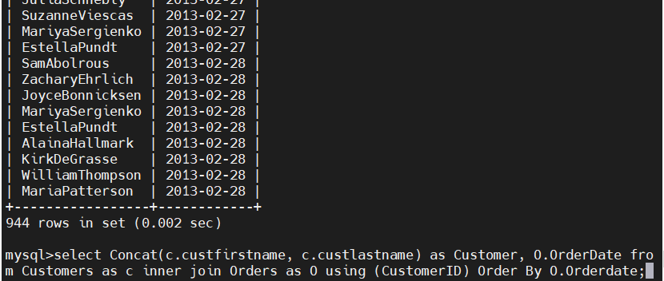

**2.** *“List employees and the customers for whom they booked an order.”*

(Hint: The solution requires a JOIN of more than two tables.)

You can find the solution in CH08_Employees_And_Customers (211 rows).

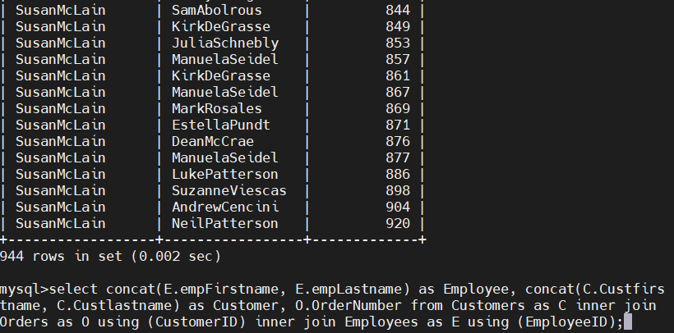

**4.** *“Show me the vendors and the products they supply to us for products that cost less than $100.”*

(Hint: The solution requires a JOIN of more than two tables.)

You can find the solution in CH08_Vendors_And_Products_Less_Than_100 (66 rows).

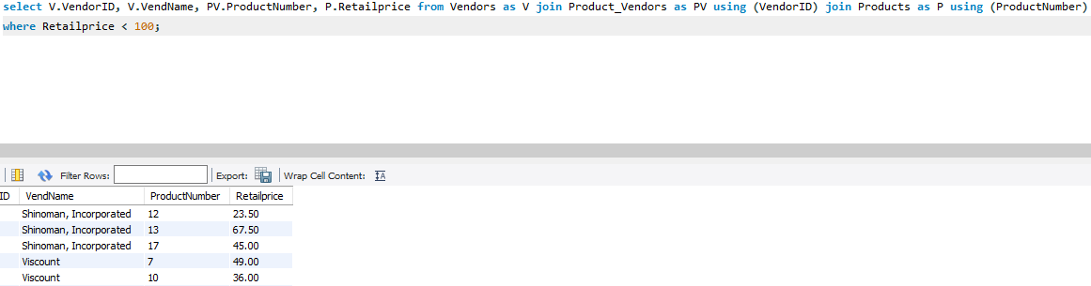

**5.** *“Show me customers and employees who have the same last name.”*

(Hint: The solution requires a JOIN on matching values.)

You can find the solution in CH08_Customers_Employees_Same_LastName (16 rows).

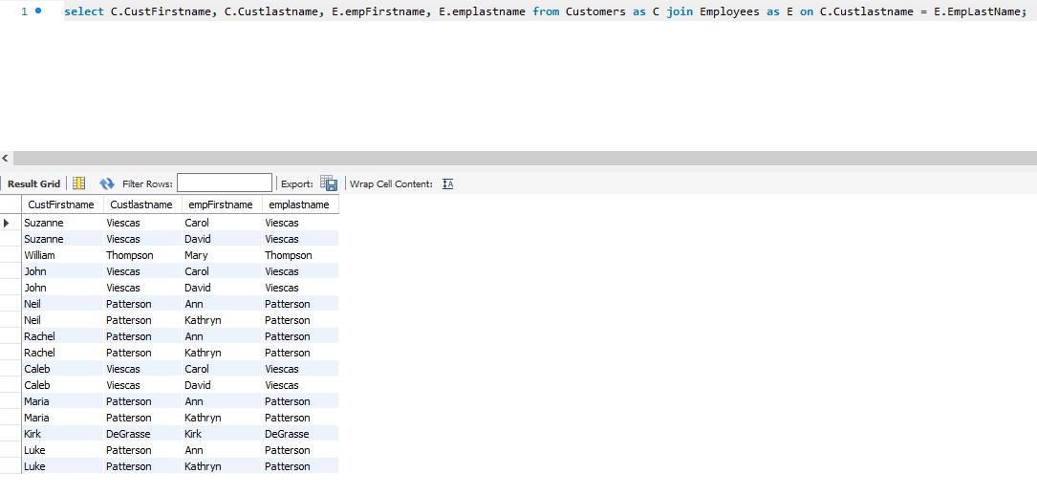

**Entertainment Agency Database**

**1.** *“Display agents and the engagement dates they booked, sorted by booking start date.”*

(Hint: The solution requires a JOIN of two tables.)

You can find the solution in CH08_Agents_Booked_Dates (111 rows).

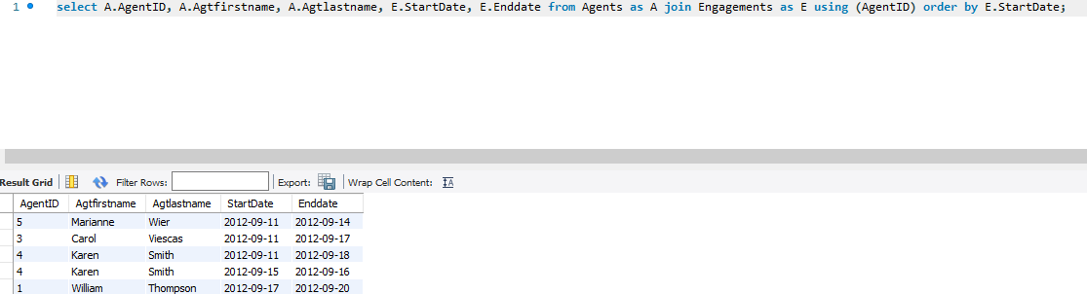

**2.** *“List customers and the entertainers they booked.”*

(Hint: The solution requires a JOIN of more than two tables.)

You can find the solution in CH08_Customers_Booked_Entertainers (75 rows).

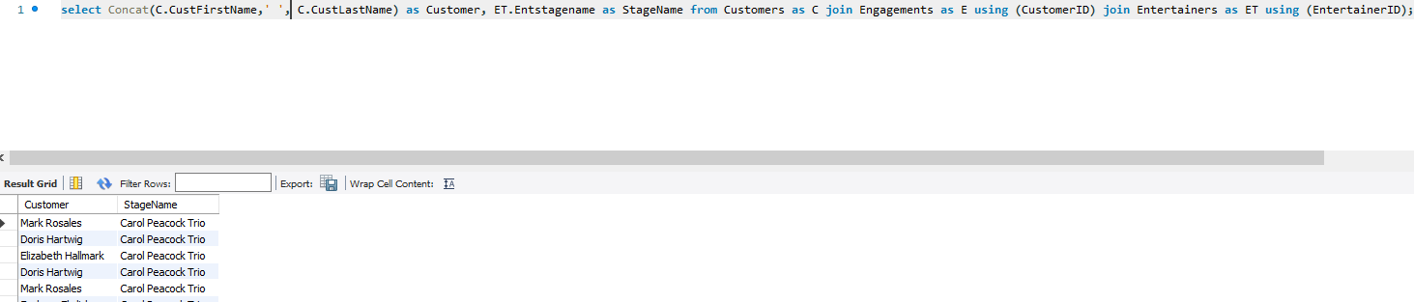

**3.** *“Find the agents and entertainers who live in the same postal code.”*

(Hint: The solution requires a JOIN on matching values.)

You can find the solution in CH08_Agents_Entertainers_Same_Postal (10 rows).

**School Scheduling Database**

**1.** *“Display buildings and all the classrooms in each building.”*

(Hint: The solution requires a JOIN of two tables.)

You can find the solution in CH08_Buildings_Classrooms (47 rows).

**3.** *“List the faculty staff and the subject each teaches.”*

(Hint: The solution requires a JOIN of more than two tables.)

You can find the solution in CH08_Staff_Subjects (110 rows).

**Bowling League Database**

**1.** *“List the bowling teams and all the team members.”*

(Hint: The solution requires a JOIN of two tables.)

You can find the solution in CH08_Teams_And_Bowlers (32 rows).

**2.** *“Display the bowlers, the matches they played in, and the bowler game scores.”*

(Hint: The solution requires a JOIN of more than two tables.)

You can find the solution in CH08_Bowler_Game_Scores (1,344 rows).

**3.** *“Find the bowlers who live in the same ZIP Code.”*

(Hint: The solution requires a JOIN on matching values, and be sure to not match bowlers with themselves.)

You can find the solution in CH08_Bowlers_Same_ZipCode (92 rows).

**Recipes Database**

**1.** *“List all the recipes for salads.”*

(Hint: The solution requires a JOIN of two tables.)

You can find the solution in CH08_Salads (1 row).

**2.** *“List all recipes that contain a dairy ingredient.”*

(Hint: The solution requires a JOIN of more than two tables.)

You can find the solution in CH08_Recipes_Containing_Dairy (2 rows).